### **What Is Planning?**

Definition: Planning is concerned with both what an organization wants to accomplish (ends) and how it will achieve these aims (means). Formal planning, the type of planning focused on here, involves:

* Defining specific goals that cover a certain time frame.
* Writing and sharing goals with all members of the organization. This reduces ambiguity and promotes a shared understanding of goals.
* Formulating plans for achieving the established goals.

### **Why Plan?**

Goals are important for setting priorities, and a well-defined plan is even more crucial when goals are set high. Planning can be a difficult process, but it is a vital part of management. The sources highlight several reasons why:

* Provides direction: When everyone in the organization knows the goals and how to achieve them, individuals and departments can work together more effectively. Without planning, they may work at cross-purposes, hindering the organization's progress.
* Reduces uncertainty: While planning cannot eliminate uncertainty, it encourages managers to anticipate changes, analyze their potential impact, and develop strategies to address them.
* Minimizes waste and redundancy: Coordinating work activities around a well-defined plan makes inefficiencies more apparent, enabling managers to correct or eliminate them.
* Establishes control standards: Planning sets goals and plans that become the benchmarks for the controlling function of management. Managers assess whether plans are being carried out and goals are being met based on these standards.

### **Important term: Means‐ends chain**

Effectively designed organizational goals fit into a hierarchy so that the achievement of goals at low levels permits the attainment of high‐level goals. This process is called a **means‐ends chain** because low‐level goals lead to accomplishment of high‐level goals.

### **Is planning worth it?**

* Formal planning is usually associated with positive financial results.
* The quality of planning and implementation are more important than the quantity of planning done.
* The external environment can reduce the impact of planning on an organization's performance.
* Formal planning needs to be done for at least four years to see effects on performance.

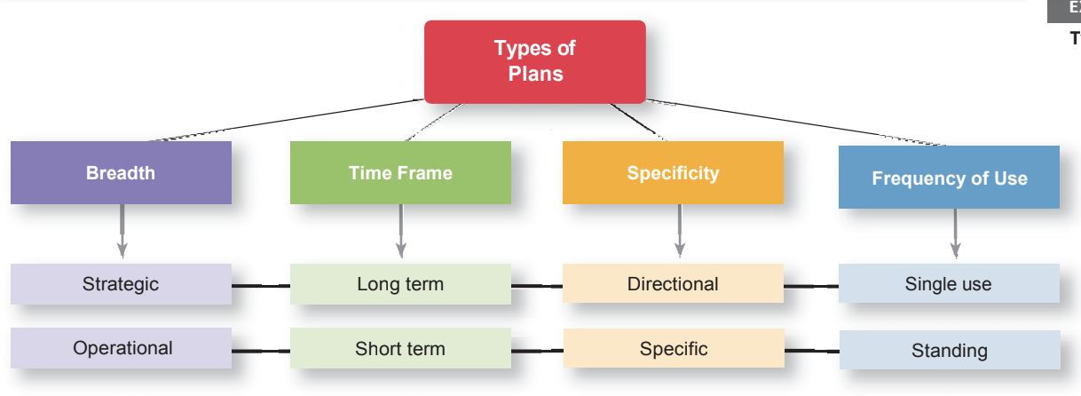

### **Four major types of plans:**

* Operational Planning
* Strategic Planning
* Tactical Planning
* Contingency Planning

Let’s dive into understanding how these types of planning optimize workspaces.

1. **Operational Planning:**

**Definition**:  
Operational planning focuses on *how things need to happen*. It provides detailed guidelines for accomplishing the organization's mission and involves setting precise, measurable operational goals.

Operational Plan: An operational plan is one that a manager uses to accomplish his or her job responsibilities.

**Types of Operational Plans**:

* **Single-Use Plans**:  
  + Created for one-time activities or events.
  + Examples: Special sales campaigns, specific project budgets.
* **Ongoing Plans**:  
  + Provide a long-term framework, revised periodically.
  + Examples include:
    - **Policies**: Broad guidelines for decision-making (e.g., hiring, performance appraisals).
    - **Procedures**: Step-by-step instructions for routine tasks (e.g., purchasing processes).
    - **Rules**: Explicit "do's and don'ts" for employee behavior (e.g., tardiness policies).

**Purpose**:  
Operational plans help supervisors, team leaders, and managers execute their responsibilities effectively, supporting broader tactical plans.

**Operational Goals**:

* Specific and measurable outcomes.
* Examples:
  + "Process 150 sales applications per week."
  + "Publish 20 books this quarter."

**Key Features**:

* Define *who*, *what*, *where*, *how*, and *how much*.
* Ensure consistency in handling recurring tasks.
* Promote fairness and safety through clearly defined rules and procedures.

### **Pictorial representation of Policies, Standards, Procedures and Guidelines**

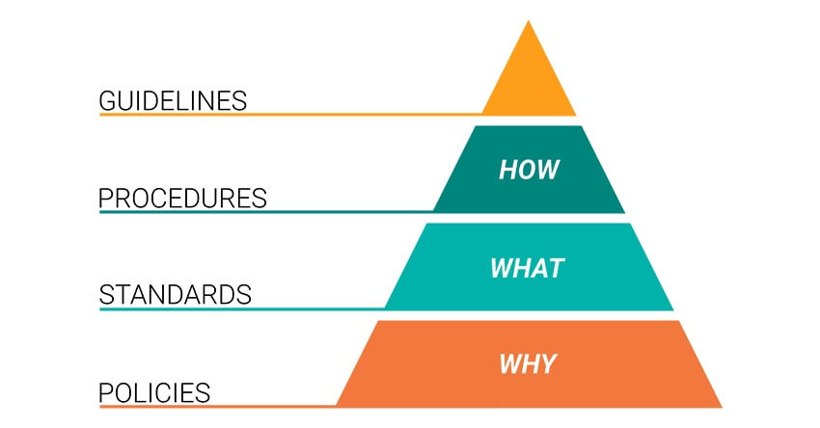

1. **Strategic Planning**

**Definition**:  
Strategic planning focuses on *why* things need to happen. It involves big-picture, long-term thinking and starts with defining the organization’s mission, vision, and values.

**Purpose**:

* Provides a high-level overview of the entire organization.
* Serves as the foundation for long-term decision-making.
* Guides the organization from its current state to its desired future.

**Scope**:

* Covers a time frame of 2 to 10 years.
* Involves collaboration across all management levels to ensure alignment.

**Key Components**:

* **Vision**: The organization’s aspirations for the future.
* **Mission**: The core purpose and reason for existence.
* **Values**: Principles guiding decisions and actions.

**Process**:

* **Top-Level Management**: Defines the organization's overarching objectives and sets the direction.
* **Lower-Level Management**: Develops compatible plans and objectives aligned with the strategic goals.
* **Integration**: Ensures alignment between levels to create a cohesive plan.

**Highlights**:

* Strategic plans focus on the organization as a whole, not individual departments.
* Require multi level involvement to ensure harmony.
* Serve as a framework for tactical and operational planning.
* Drive long-term success by aligning efforts with the organization's mission and vision.

**Example**:  
A company looking to expand its market presence over the next five years will create a strategic plan outlining objectives such as entering new geographic regions, enhancing brand awareness, and investing in innovative product development.

1. **Tactical Planning**

**Definition:**

* Tactical planning focuses on what is going to happen. It breaks down high-level strategic plans into specific, focused, and short-term actions that support the broader strategy.

**Purpose:**

* Converts strategic goals into actionable steps.
* Provides direction for lower-level units within the organization.
* Ensures alignment with the organization’s strategic vision.

**Scope:**

* Covers a shorter time frame, typically less than one year.
* Addresses specific tasks or projects within a division or department.

**Key Features:**

* Specificity: Outlines detailed actions and tasks to achieve strategic objectives.
* Responsibility: Identifies who is in charge at various levels.
* Focus: Narrower scope compared to strategic planning, with clearly defined outcomes.

**Process:**

* Middle Management:
* Translates the strategic plan into tactical actions.
* Focuses on short-term, achievable goals.
* Coordination:
* Ensures all tactical plans align with and support the strategic plan.

Comparison of Strategy vs Tactical Planning

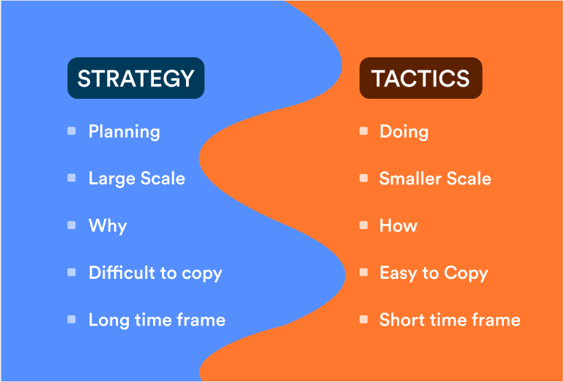

Example:

If the strategic plan aims to increase market share, a tactical plan could include specific actions like launching a targeted marketing campaign, expanding the sales team, or introducing promotional discounts in a particular region.

Tactical planning bridges the gap between strategic goals and operational tasks, ensuring a smooth flow of activities toward organizational success.

1. **Contingency Planning**

**Definition**:  
Contingency planning involves preparing alternative courses of action to address unexpected events or changing circumstances that make the original plan inadequate.

**Purpose**:

* Ensures adaptability and flexibility in unpredictable situations.
* Provides a backup plan to mitigate risks and minimize disruptions.
* Helps maintain progress toward organizational goals despite unforeseen challenges.

**Key Features**:

* **Adaptability**: Anticipates potential changes and prepares alternative actions.
* **Flexibility**: Keeps options open to quickly respond to unexpected developments.
* **Proactive Approach**: Identifies risks and outlines responses during the planning process.

**Importance**:

* Vital in a complex and dynamic business environment.
* Helps managers respond effectively to events beyond their control.
* Enhances the organization’s resilience and ability to recover from setbacks.

**Process**:

1. **Risk Identification**: Assess potential risks or scenarios where plans might fail.
2. **Alternative Planning**: Develop alternative strategies to address each identified risk.
3. **Implementation Readiness**: Keep contingency plans updated and ready for deployment.

**Key Principles**:

* Always anticipate change and prepare for unexpected events.
* Incorporate flexibility into planning processes.
* Ensure alignment between contingency plans and overall organizational goals.

**Example**:  
If a company’s primary supplier fails to deliver raw materials due to unforeseen circumstances, a contingency plan could include using an alternate supplier or leveraging existing inventory to maintain operations.

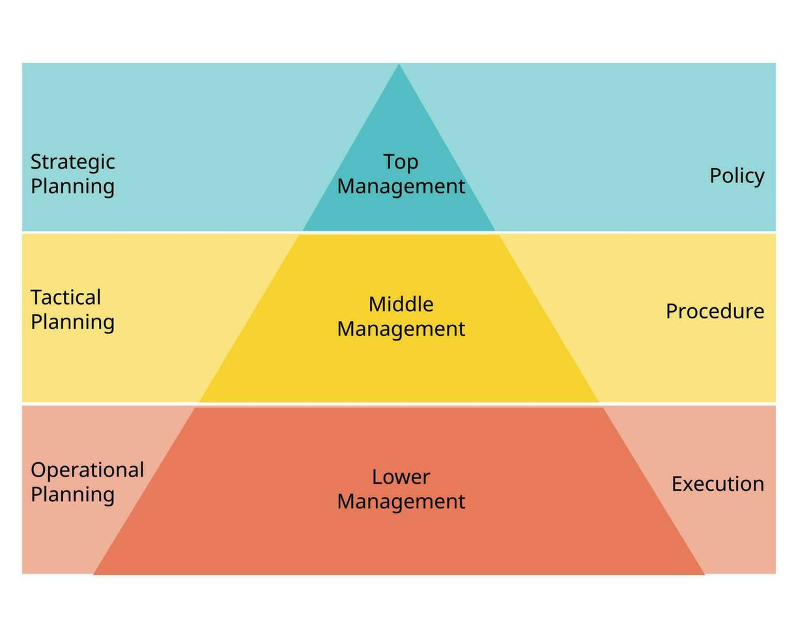

### **The Evolution of the Concept of Strategy**

#### **1. Strategy as the Grand Plan**

* **Origin**: Derived from the Greek word *strategeia*, meaning "the art or science of being a General."
* **Military Context**:
  + Involved leading armies, securing territories, defending cities, and defeating enemies.
  + Required resource deployment based on objectives.
  + Strategy included planning and decision-making/action to respond effectively to the enemy.
* **Key Aspects of Military Strategy**:
  + Lines of supply.
  + Timing of battles (when to fight or retreat).
  + Managing relationships with citizens, politicians, and diplomats.
* **Core Idea**: Strategy integrates planning and action, forming a "grand strategy plan."

#### **2. The Rise of Strategic Management**

* **Post-World War II Development**:
  + Strategy evolved into a management process termed *strategic management*.
  + Involves both planning and implementing strategies within organizations.
* **Definition by Alfred D. Chandler (1962)**:
  + Strategy is "the determination of the basic long-term goals and objectives of an enterprise, and the adoption of courses of action and the allocation of resources necessary for carrying out these goals."
* **Key Focus**:
  + How an organization achieves its mission.
  + Competes successfully in the market.
  + Attracts and satisfies customers to accomplish its goals.

### **The Strategic Management Process**

Managers can use strategic management as a methodical approach to understand the environment in which their firm planned and then takes action. A six-step framework for planning, implementing, and evaluating strategies effectively.

#### **1. Identify Mission, Goals, and Strategies**

* Define the organization's purpose and current objectives.
* Understand existing strategies to establish a starting point.

#### **2. Perform SWOT Analysis**

* **External Analysis**:
  + **Opportunities**: Factors to leverage (e.g., market trends).
  + **Threats**: Risks to address (e.g., competition).
* **Internal Analysis**:
  + **Strengths**: Assets that provide an advantage.
  + **Weaknesses**: Limitations to improve.

#### **3. Formulate Strategies**

* Develop actionable plans based on the SWOT analysis.
* Align goals with opportunities while mitigating threats and weaknesses.

#### **4. Implement Strategies**

* Allocate resources, assign responsibilities, and ensure team alignment.
* Translate plans into action across all levels.

#### **5. Evaluate Results**

* Measure outcomes against objectives.
* Identify deviations and adjust strategies as needed.

Strategic management offers a structured approach for managers to understand the environment in which their organization operates and then take appropriate actions. In general, this process involves **two main phases**:  
 **Strategic Planning**: Refers to the process of making sense of the situation, which includes both goal setting and strategy formulation.  
 **Strategy Implementation**: Refers to the actions taken based on the planning. This phase encompasses both the administration of the strategy and the strategic control stages.

In their synthesis of strategic management, Hofer and Schendel highlighted four essential aspects that together form the core of the strategic management process.

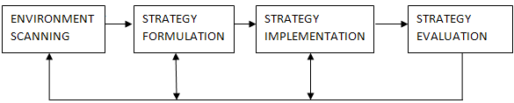

**1. Goal Setting**

The first and foundational step in the strategic management process is goal setting. In this phase, the organization defines its long-term objectives, determining what it aims to achieve in the future. These goals should be clear, measurable, and aligned with the organization’s mission and vision

**2. Strategy Formulation**

Once the goals are set, the next step is strategy formulation, which involves developing a set of actions or strategies that will help the organization achieve its goals. This phase requires managers to analyze internal and external factors (such as market trends, competitors, resources, and capabilities) and choose the best course of action.

**3. Administration**

After formulating the strategy, the focus shifts to strategy implementation, or administration, which is the process of putting the planned strategies into action. This phase moves from analysis to practical execution, where the organization’s plans are turned into reality.

**4. Feedback and Adjustment**

The final phase, strategic control, involves monitoring and evaluating the progress of the strategy's implementation. It provides managers with feedback on how well the organization is performing relative to the goals and objectives.

**Types of Organizational Strategies**

Organizational strategies are broad approaches designed to achieve specific goals and guide decision-making at various levels within an organization. Here’s a breakdown of the types mentioned:

1. **Corporate Strategy**

Corporate strategy involves decisions that determine the overall scope and direction of an organization, it focuses on the overall scope and direction of an organization. It determines the industries and markets in which the organization will operate.

Here are the major types of corporate strategies:

**1**.**Growth Strategies:** Focus on increasing the organization’s market share, revenue, or geographic reach.

**Example:** McDonald's focusing on expanding its number of outlets within the fast-food industry.

**2.Stability Strategies:** Focus on maintaining the current business and operations to ensure consistent performance.

**Example:** A local bakery continuing to operate with the same product offerings and pricing in its community.

**3. Retrenchment Strategies:** Focus on reducing the scope or scale of operations to improve financial stability or refocus resources.

**Example:** Ford restructuring its operations in the 2000s by closing unprofitable plants and focusing on popular vehicle lines like SUVs and trucks.

**4. Portfolio Strategies:** Focus on managing a group of businesses to maximize overall performance

**Example:** General Electric evaluating its business units, such as healthcare and aviation, based on market attractiveness and competitive strength.

**5. International/Global Strategies:** Focus on expanding operations across borders.

**Example:** Nestlé customizing its products (e.g., Maggi noodles with local flavors) to suit regional preferences in India and other markets.

**Corporate portfolio matrix**

The **Corporate Portfolio Matrix** is a strategic tool that helps organizations analyze and manage their portfolio of business units, products, or investments to align with overall corporate objectives. It provides a framework for resource allocation and strategic decision-making based on the performance and strategic positioning of each unit.

One of the best-­known examples of a corporate portfolio matrix is the portfolio framework advocated by the Boston consulting Group. This framework is known as the BCG Matrix.The BCG approach to analyzing a corporate portfolio of businesses focuses on three aspects of each particular businesses unit: its sales, the growth of its market, and whether it absorbs or produces cash in its operations

**BCG Matrix**

### **Purpose of the BCG Matrix**

* Helps prioritize investments and resource allocation.
* Identifies products or units to grow, maintain, or phase out.
* Balances the portfolio by ensuring a mix of growth (Stars), stability (Cash Cows), and experimentation (Question Marks).

The matrix is divided into four quadrants based on two factors:

1. **Market Growth Rate** (vertical axis): Indicates the growth potential of the industry or market.
2. **Relative Market Share** (horizontal axis): Measures the unit's share of the market relative to its largest competitor.

The quadrants are:

1. **Stars**

* Stars represent products or business units with a high market growth rate and a high relative market share.
* These are market leaders in fast-growing industries and often require significant investment to sustain growth.
* The strategy for Stars is to invest in them to maintain or enhance their position, eventually transitioning them into Cash Cows as market growth slows.
* An example of a Star would be Apple’s iPhone during its peak growth phase.

1. **Cash Cows**

* Cash Cows are products or business units with a high relative market share in a low-growth market.
* These are mature and established offerings that generate consistent, high profits with minimal investment.
* The strategy for Cash Cows is to “milk” their profits to fund Stars and Question Marks while maintaining operational efficiency.
* Coca-Cola’s classic soda in the mature beverage market is an example of a Cash Cow.

1. **Question Marks**

* Question Marks are products or business units in high-growth markets but with a low relative market share.
* They have uncertain potential; with proper investment, they could become Stars, but without it, they may fail and turn into Dogs.
* The strategy for Question Marks is to assess their viability carefully and invest selectively in those with high potential, while divesting the rest.
* An example of a Question Mark might be a new electric vehicle model introduced by a lesser-known car manufacturer.

1. **Dogs**

* Dogs represent products or business units in markets with low growth rates and low relative market shares.
* They often have limited potential and generate minimal profits, making them non-essential to the organization’s portfolio.
* The strategy for Dogs is typically to divest or phase them out unless they serve a specific strategic purpose.
* An example of a Dog is DVD players in the declining home entertainment market.

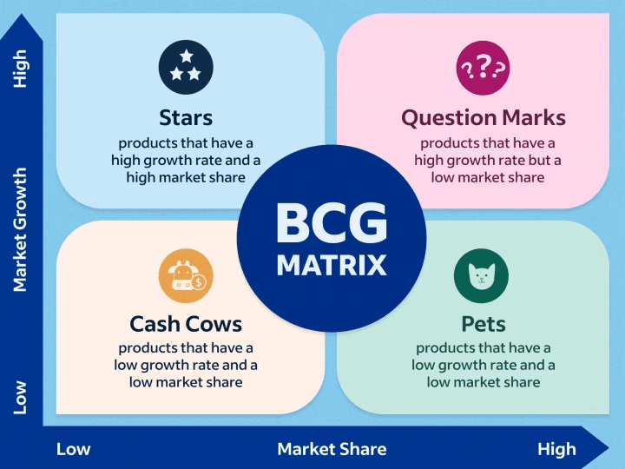

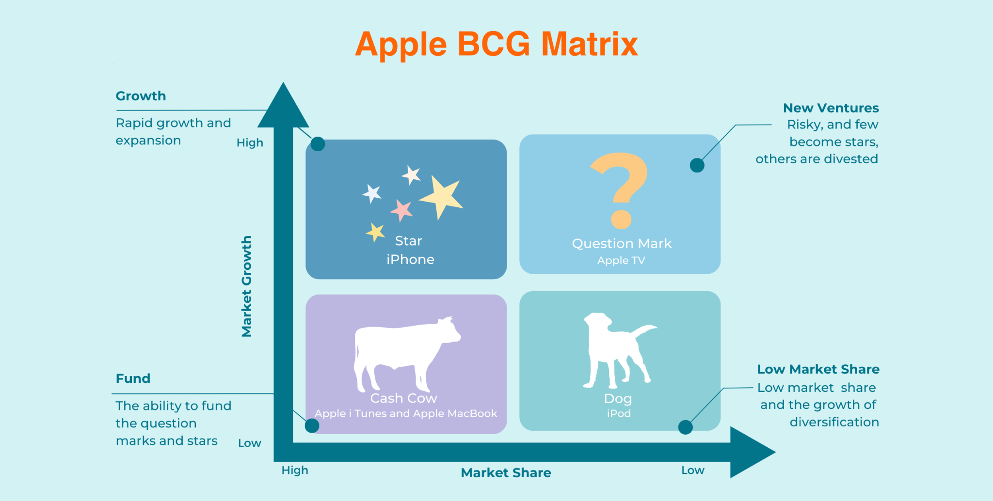

**2. Competitive Strategy**

Competitive strategies are approaches that businesses use to gain an advantage in the market and outperform competitors.It involves making deliberate choices about how to position the company, differentiate its offerings, and satisfy customer needs better than competitors.

**Key Approaches**

* Cost Leadership: Achieving lower costs to offer products/services at competitive prices.
* Differentiation: Offering unique products or services that command a premium price.
* Focus: Concentrating on a niche market and excelling in that segment.

Examples: A company differentiating its product by focusing on innovation or branding

### **The Five Forces Model**

#### **Threat of New Entrants**

* The threat of new entrants evaluates how easily new competitors can enter the market and challenge existing businesses.
* Barriers to entry, such as economies of scale, brand loyalty, and regulatory requirements, influence the ease of market entry.
* If barriers to entry are low, companies often adopt a cost leadership strategy to deter new competitors by keeping prices low.
* Differentiation strategies can help businesses build strong brand loyalty, making it difficult for new entrants to capture market share.

#### **Bargaining Power of Suppliers**

* The bargaining power of suppliers measures their ability to influence the price, quality, or availability of inputs.
* Factors such as the number of suppliers, availability of substitute inputs, and uniqueness of supplies determine supplier power.
* Companies can counter strong supplier power by backward integration, taking control of their supply chain to reduce dependency.
* Alternatively, differentiation can enable businesses to absorb higher input costs by offering unique and high-value products.

#### 

#### **Bargaining Power of Buyers**

* The bargaining power of buyers refers to their ability to demand lower prices or higher-quality products.
* It depends on factors such as the number of buyers, availability of alternatives, and customer price sensitivity.
* A cost leadership strategy can appeal to price-sensitive buyers by offering competitive pricing.
* Differentiation strategies attract buyers willing to pay a premium for unique or high-quality products, reducing price sensitivity.

#### **Threat of Substitute Products or Services**

* The threat of substitutes assesses the likelihood of customers switching to alternative products or services.
* Factors influencing this threat include the availability of substitutes, cost of switching, and the perceived value of alternatives.
* Differentiation reduces the risk of substitutes by emphasizing unique features, quality, or customer experience.
* Cost leadership can counter substitutes by offering competitive pricing, making alternatives less attractive.

#### **Industry Rivalry**

* Industry rivalry measures the intensity of competition among current players within the market.
* The level of rivalry is influenced by factors such as the number of competitors, market growth rate, and product differentiation.
* Cost leadership is effective in highly competitive industries, as it allows businesses to compete aggressively on price.
* Differentiation strategies help businesses stand out by offering unique products or services, reducing direct competition.

**GOALS**

Setting goals aids in a company's expansion and goal-achieving. They can be used to assist the firm articulate its goals and promote teamwork. Establishing objectives is a crucial component of any business plan.

### **6 Types of Goal Setting**

Goal setting is a structured process of identifying and planning objectives that guide personal or organizational efforts. Different types of goals cater to various aspects of growth and achievement. Below are six key types of goal setting:

#### **Strategic Goal Setting**

* **Focus**: Long-term, big-picture objectives that align with the overall vision or mission.
* **Purpose**: Define a clear direction for success over an extended timeframe.
* **Example**: A company aiming to expand into three new international markets within five years.

#### **Performance Goal Setting**

* **Focus**: Measuring specific outcomes or results.
* **Purpose**: Track progress and performance through quantifiable metrics.
* **Example**: Increasing sales revenue by 20% in the next fiscal year.

#### **Learning Goal Setting**

* **Focus**: Developing new skills, knowledge, or competencies.
* **Purpose**: Enhance personal or professional growth.
* **Example**: Completing a certification course in digital marketing within six months.

#### **Process Goal Setting**

* **Focus**: The steps or actions required to achieve a larger goal.
* **Purpose**: Break down big goals into manageable, actionable tasks.
* **Example**: Conducting weekly team meetings to track the progress of a product launch.

#### **Outcome Goal Setting**

* **Focus**: Specific results or end achievements.
* **Purpose**: Define clear targets that represent success.
* **Example**: Winning a national industry award for innovation.

#### **Social/Impact Goal Setting**

* **Focus**: Goals that benefit society or create positive change.
* **Purpose**: Foster a sense of purpose and responsibility beyond individual or organizational interests.
* **Example**: Reducing company-wide carbon emissions by 30% within three years.

### **Things to Consider While Setting Business Goals**

Setting business goals is a critical step in ensuring an organization’s success. Thoughtful goal-setting requires considering various factors to ensure that objectives are realistic, achievable, and aligned with the organization's mission. Here are key considerations

When you put all of your energy into trying to expand the business, it's easy to lose sight of your own motivations.

Getting more clients or making more money are likely the first things that come to mind when you think about potential business objectives. Although those objectives are significant, they are merely one aspect of the whole.

Recall your motivations for starting your business or freelancing. Spending more time with your family and having more flexibility may have inspired you. Perhaps you wanted to enjoy your work more or be more creative. These are priorities that extend beyond merely meeting sales and income goals. All those other things are made feasible by income, but money is rarely a goal in itself.

When you’re setting goals, go beyond the obvious business-related areas. Consider things like:

* The maximum number of hours you want to work each week
* Specific days or time slots you want to have off
* Never missing your children’s sports days and performances
* Fitting in your yoga and meditation every day
* Gaining a specific qualification

## **Long-term vs. short-term business goals**

Maintaining a balance between short-term objectives and long-term vision can keep you inspired and intent on the steps you need to take to realize that vision.

Think about the timeline for reaching your goals as you establish your career and personal objectives. Even if you may have lofty goals for the future, it's simple to put things off when there are no deadlines to meet. However, short-term objectives may cause you to make small steps forward without having something more significant to strive for, which can cause you to lose sight of the wider picture.

Setting both short-term and long-term business goals is the best course of action. First, develop a broad vision that will motivate you and provide you with a worthwhile goal to strive for. To concentrate your immediate efforts, divide that into more manageable objectives with shorter turnaround times.

A big picture or lifetime vision might include:

* Reaching a specific income level
* Establishing a passive income stream
* Retiring early and traveling the world
* Relocating to a new country
* Buying your dream house

Divide this vision into several long-term objectives that you can accomplish in a year, three years, five years, or ten years.

A three-month deadline for short-term objectives is both long enough to yield significant results and short enough to keep you focused. Divide these objectives into weekly and monthly targets to make them even more attainable.

## **Outcome vs. process business goals**

We should take into account both the desired goal (the results) and the necessary steps to achieve it (the process).

In the end, your business objectives must produce outcomes. In a sense, it doesn't really matter how you get there—what will motivate you is your future result!

You don't always have total control over whether or not you'll achieve your outcome goals, which are closely tied to the outcomes you're hoping for. You must do some things to increase the likelihood of achieving that result. Process goals can help with that.

Process goals are related to things you do have control over. For example:

* Sending a specific number proposals every week
* Following up with prospective clients every day
* Posting regularly on your social media channels
* Blocking your calendar to spend time with your family
* Signing up to an online course

Once more, you should combine the two kinds of objectives. While process goals are best suited for your immediate deadlines, outcome goals typically align with your long-term vision. For instance, your three-month objective might be to acquire five new clients, your weekly goal might be to send at least five new proposals, and your one-year goal would be to raise your income by fifty percent.

## **Quantitative vs. qualitative business goals**

## Although financial metrics will be useful in ensuring that the business is on track, you should also set other, less measurable goals for yourself.

## Business objectives must be sufficiently detailed to allow for tracking and the determination of their accomplishment. "Growing the business," "getting more clients," and "spending more time with my children" are all far too ambiguous.

## SMART stands for specified, measurable, and achievable goals, which are ensured by quantitative goals. Here are some instances of quantitative objectives:

* Earn $10,000 in the next three months
* Get three new clients by the end of the month
* Work no more than 30 hours this week on the business

However, business goals that you can’t measure with numbers can be just as important. Qualitative goals might include:

* Feeling more confident
* Experiencing less stress
* Enjoying your work more
* Improving your writing or public speaking skills
* Finding a better balance between work and your personal life

Give as much detail as you can by stating what "better" or "more" you want of anything. Scales are also helpful. Set a target for three months from now (8 out of 10) after rating your confidence now (e.g., 6 out of 10). This will allow you to evaluate your progress toward less concrete objectives.

As usual, be sure to balance the two kinds of objectives. Establish qualitative goals to capture the more subtle facets of your business's objectives, and quantitative goals to ensure that you're meeting your financial aims.

**Organizational structure and design**

For Empire to be successful, the management structure requires simplicity and clarity.

**Organizational Structure**: A short distance south of McAlester, Oklahoma, employees in a vast factory complex make products that must be perfect. These people “are so good at what they do and have been doing it for so long that they have a 100 percent market share.” They make bombs for the U.S. military and doing so requires a work environment that’s an interesting mix of the mundane, structured, and disciplined, coupled with high levels of risk and emotion. The work gets done efficiently and effectively here. Work also gets done efficiently and effectively at Cisco Systems although not in such a structured and formal way. At Cisco, some 70 percent of the employees work from home at least 20 percent of the time. Both of these organizations get needed work done although each does so using a different structure. Few topics in management have undergone as much change in the past few years as that of organizing and organizational structure.

Managers are reevaluating traditional approaches to find new structural designs that best support and facilitate employees’ doing the organization’s work—designs that can achieve efficiency but are also flexible. The basic concepts of organization design formulated by early management writers, such as Henri Fayol and Max Weber, offered structural principles for managers to follow. (Those principles are described on pp. 31–32.) Over 90 years have passed since many of those principles were originally proposed. Given that length of time and all the changes that have taken place, you’d think that those principles would be pretty worthless today. Surprisingly, they’re not. For the most part, they still provide valuable insights into designing effective and efficient organizations. Of course, we’ve also gained a great deal of knowledge over the years as to their limitations.

**Organizing:** arranging and structuring work to accomplish an organization goals.

Purpose of organizing:

o Divides work to be done into specific jobs and departments,

o Assigns tasks and responsibilities associated with individual jobs,

o Coordinates diverse organizational tasks,

o Clusters job into units,

o Establishes relationships among individuals, groups and departments,

o Establishes formal lines of authority, o Allocates and deploys organizational resources.

**Work specialization:** Work specialization makes efficient use of the diversity of skills that workers have. In most organizations, some tasks require highly developed skills; others can be performed by employees with lower skill levels. If all workers were engaged in all the steps of, say, a manufacturing process, all would need the skills necessary to perform both the most demanding and the least demanding jobs. Thus, except when performing the most highly skilled or highly sophisticated tasks, employees would be working below their skill levels. In addition, skilled workers are paid more than unskilled workers, and, because wages tend to reflect the highest level of skill, all workers would be paid at highly skilled rates to do easy tasks—an inefficient use of resources. This concept explains why you rarely find a cardiac surgeon closing up a patient after surgery. Instead, doctors doing their residencies in openheart surgery and learning the skill usually stitch and staple the patient after the surgeon has finished the surgery. Early proponents of work specialization believed that it could lead to great increases in productivity. At the beginning of the twentieth century, that generalization was reasonable. Because specialization was not widely practiced, its introduction almost always generated higher productivity. But, as Exhibit 10-2 illustrates, a good thing can be carried too far. At some point, the human diseconomies from division of labor—boredom, fatigue, stress, low productivity, poor quality, increased absenteeism, and high turnover—exceed the economic advantages

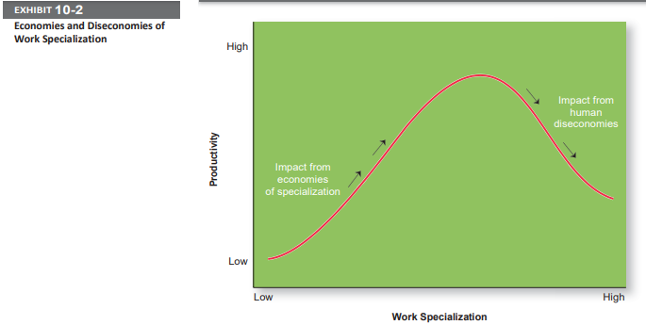

**Departmentalization:** After deciding what job tasks will be done by whom, common work activities need to be grouped back together so work gets done in a coordinated and integrated way. How jobs are grouped together is called departmentalization. Five common forms of departmentalization are used, although an organization may develop its own unique classification. (For instance, a hotel might have departments such as front desk operations, sales and catering, housekeeping and laundry, and maintenance.) Exhibit 10-3 illustrates each type of departmentalization as well as the advantages and disadvantages of each.

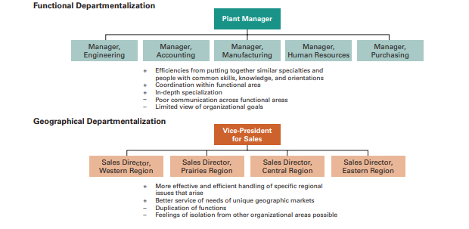

Most large organizations continue to use combinations of most or all of these types of departmentalization. For example, a major Japanese electronics firm organizes its divisions along functional lines, its manufacturing units around processes, its sales units around seven geographic regions, and its sales regions into four customer groupings. Black & Decker organizes its divisions along functional lines, its manufacturing units around processes, its sales around geographic regions, and its sales regions around customer groupings.

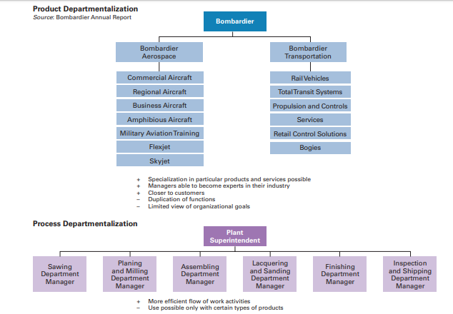

One popular departmentalization trend is the increasing use of customer departmentalization. Because getting and keeping customers is essential for success, this approach works well because it emphasizes monitoring and responding to changes in customers’ needs. Another popular trend is the use of teams, especially as work tasks have become more complex and diverse skills are needed to accomplish those tasks. One specific type of team that more organizations are using is a cross-functional team, which is a work team composed of individuals from various functional specialties. For instance, at Ford’s material planning and logistics division, a cross-functional team of employees from the company’s finance, purchasing, engineering, and quality control areas, along with representatives from outside logistics suppliers, has developed several work improvement ideas.

**Chain of command**

 People need to know who their boss is. That’s what the chain of command is all about. The chain of command is the line of authority extending from upper organizational levels to lower levels, which clarifies who reports to whom. Managers need to consider it when organizing work because it helps employees with questions such as “Who do I report to?” or “Who do I go to if I have a problem?” To understand the chain of command, you have to understand three other important concepts: authority, responsibility, and unity of command. Let’s look first at authority. There are three important concepts attached to this theory:

* Authority: Authority was a major concept discussed by the early management writers; they viewed it as the glue that held an organization together. Authority refers to the rights inherent in a managerial position to tell people what to do and to expect them to do it.8 Managers in the chain of command had authority to do their job of coordinating and overseeing the work of others. Authority could be delegated downward to lower-level managers, giving them certain rights while also prescribing certain limits within which to operate. These writers emphasized that authority was related to one’s position within an organization and had nothing to do with the personal characteristics of an individual manager. They assumed that the rights and power inherent in one’s formal organizational position were the sole source of influence and that if an order was given, it would be obeyed. Chester Barnard, proposed another perspective on authority. This view, called the acceptance theory of authority, says that authority comes from the willingness of subordinates to accept it. If an employee didn’t accept a manager’s order, there was no authority. Barnard contended that subordinates will accept orders only if the following conditions are satisfied:

1. They understand the order.

2. They feel the order is consistent with the organization’s purpose.

3. The order does not conflict with their personal beliefs.

4. They are able to perform the task as directed.

Line authority entitles a manager to direct the work of an employee. It is the employer–employee authority relationship that extends from the top of the organization to the lowest echelon, according to the chain of command, as shown in Exhibit 10.4. As organizations get larger and more complex, line managers find that they do not have the time, expertise, or resources to get their jobs done effectively. In response, they create staff authority functions to support, assist, advise, and generally reduce some of their informational burdens. For instance, a hospital administrator who cannot effectively handle the purchasing of all the supplies the hospital needs creates a purchasing department, which is a staff function. Of course, the head of the purchasing department has line authority over the purchasing agents who work for him. The hospital administrator might also find that she is overburdened and needs an assistant, a position that would be classified as a staff position. Exhibit 10-5 illustrates line and staff authority.

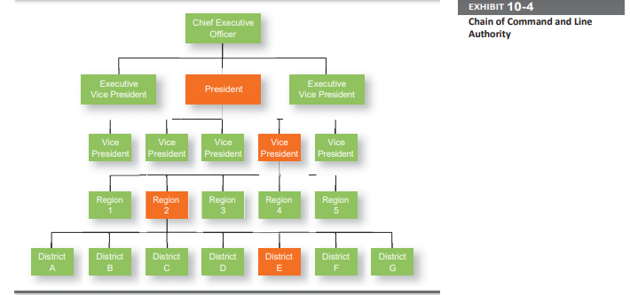

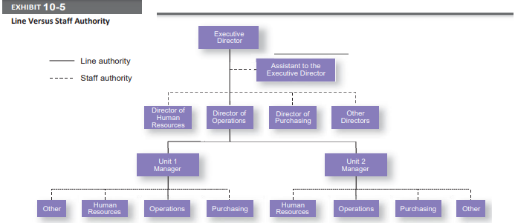

* Responsibility: When managers use their authority to assign work to employees, those employees take on an obligation to perform those assigned duties. This obligation or expectation to perform is known as responsibility. And employees should be held accountable for their performance! Assigning work authority without responsibility and accountability can create opportunities for abuse. Likewise, no one should be held responsible or accountable for work tasks over which he or she has no authority to complete those tasks.
* Unity of command: Finally, the unity of command principle (one of Fayol’s 14 management principles) states that a person should report to only one manager. Without unity of command, conflicting demands from multiple bosses may create problems as it did for Damian Birkel, a merchandising manager in the Fuller Brands division of CPAC, Inc. He found himself reporting to two bosses—one in charge of the department-store business and the other in charge of discount chains. Birkel tried to minimize the conflict by making a combined to-do list that he would update and change as work tasks changed
* **Span of Control**

How many employees can a manager efficiently and effectively manage? That’s what span of control is all about. The traditional view was that managers could not—and should not— directly supervise more than five or six subordinates. Determining the span of control is important because to a large degree, it determines the number of levels and managers in an organization—an important consideration in how efficient an organization will be. All other things being equal, the wider or larger the span, the more efficient an organization is. Here’s why. Assume two organizations, both of which have approximately 4,100 employees. As Exhibit 10-6 shows, if one organization has a span of four and the other a span of eight, the organization with the wider span will have two fewer levels and approximately 800 fewer managers. At an average manager’s salary of $42,000 a year, the organization with the wider span would save over $33 million a year! Obviously, wider spans are more efficient in terms of cost. However, at some point, wider spans may reduce effectiveness if employee performance worsens because managers no longer have the time to lead effectively.

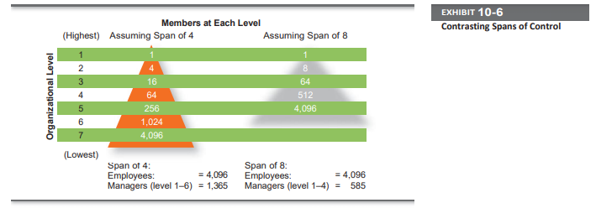

**Today’s View**: The contemporary view of span of control recognizes that many factors influence the appropriate number of employees a manager can efficiently and effectively manage. These factors include the skills and abilities of the manager and the employees, and the characteristics of the work being done. **For example,** the more training and experience employees have, the less direct supervision they need. Therefore, managers with well-trained and experienced employees can function quite well with a wider span. Other contingency variables that determine the appropriate span include similarity of employee tasks, the complexity of those tasks, the physical proximity of subordinates, the degree to which standardized procedures are in place, the sophistication of the organization’s information system,the strength of the organization’s culture, and the preferred style of the manager.7 Wider spans of control are also possible due to technology—it is easier for managers and their subordinates to communicate with each other, and there is often more information readily available to help employees perform their jobs.

**Centralization and decentralization:** One of the questions that needs to be answered when organizing is “At what organizational level are decisions made?” Centralization is the degree to which decision making takes place at upper levels of the organization. If top managers make key decisions with little input from below, then the organization is more centralized. On the other hand, the more that lower-level employees provide input or actually make decisions, the more decentralization there is. Keep in mind that centralization-decentralization is not an either-or concept. The decision is relative, not absolute—that is, an organization is never completely centralized or decentralized. Early management writers proposed that the degree of centralization in an organization depended on the situation. Their goal was the optimum and efficient use of employees. Traditional organizations were structured in a pyramid, with power and authority concentrated near the top of the organization. Given this structure, historically centralized decisions were the most prominent, but organizations today have become more complex and responsive to dynamic changes in their environments. As such, many managers believe that decisions need to be made by those individuals closest to the problems, regardless of their organizational level. In fact, the trend over the past several decades—at least in U.S. and Canadian organizations— has been a movement toward more decentralization in organizations. Exhibit 10-7 lists some of the factors that affect an organization’s use of centralization or decentralization.

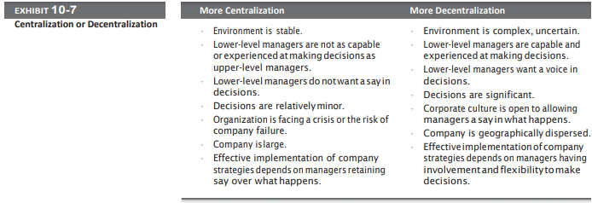

As organizations have become more flexible and responsive to environmental trends, there’s been a distinct shift toward decentralized decision making. This trend, also known as employee empowerment, gives employees more authority (power) to make decisions.

**Formalization:** Formalization refers to how standardized an organization’s jobs are and the extent to which employee behavior is guided by rules and procedures. In highly formalized organizations, there are explicit job descriptions, numerous organizational rules, and clearly defined procedures covering work processes. Employees have little discretion over what’s done, when it’s done, and how it’s done. However, where formalization is low, employees have more discretion in how they do their work. TODAY’S VIEW. Although some formalization is necessary for consistency and control, many organizations today rely less on strict rules and standardization to guide and regulate employee behavior. For instance, consider the following situation: A customer comes into a branch of a large national drug store and drops off a role of film for same-day developing minutes after the store policy cut-off time. Although the sales clerk know she’s supposed to follow rules, he also know she could get the film developed with no problem and wants to accommodate the customer. So he accepts the film, violating policy, hoping that his manager won’t find out.22 Has this employee done something wrong? He did “break” the rule. But by “breaking” the rule, he actually brought in revenue and provided good customer service. Considering there are numerous situations where rules may be too restrictive, many organizations have allowed employees some latitude, giving them sufficient autonomy to make those decisions that they feel are best under the circumstances. It doesn’t mean throwing out all organizational rules because there will be rules that are important for employees to follow—and these rules should be explained so employees understand why it’s important to adhere to them. But for other rules, employees may be given some leeway.

**Mechanistic & Organic Structures:**

Stocking extra swimsuits in retail stores near water parks seems to make sense, right? And if size 11 women’s shoes have been big sellers in Chicago, then stocking more size 11s seems to be a no-brainer. After suffering through 16 months of declining same-store sales, Macy’s CEO Terry Lundgren decided it was time to restructure the organization to make sure that these types of smart retail decisions are made.25 He’s making the company both more centralized and more locally focused. Although that may seem a contradiction, the redesign seems to be working. Lundgren centralized Macy’s purchasing, planning, and marketing operations from seven regional offices to one office at headquarters in New York. He also replaced regional merchandise managers with more local managers— each responsible for a dozen stores—who spend more time figuring out what’s selling.

Designing (or redesigning) an organizational structure that works is important. Basic organizational design revolves around two organizational forms that are described in Exhibit 10-8.26.

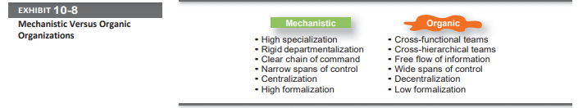

The mechanistic organization (or bureaucracy) was the natural result of combining the six elements of structure. Adhering to the chain-of-command principle ensured the existence of a formal hierarchy of authority, with each person controlled and supervised by one superior. Keeping the span of control small at increasingly higher levels in the organization created tall, impersonal structures. As the distance between the top and the bottom of the organization expanded, top management would increasingly impose rules and regulations. Because top managers couldn’t control lower-level activities through direct observation and ensure the use of standard practices, they substituted rules and regulations. The early management writers’ belief in a high degree of work specialization created jobs that were simple, routine, and standardized. Further specialization through the use of departmentalization increased impersonality and the need for multiple layers of management to coordinate the specialized departments.

## The **organic organization** is a highly adaptive form that is as loose and flexible as the mechanistic organization is rigid and stable. Rather than having standardized jobs and regulations, the organic organization’s loose structure allows it to change rapidly as required.27 It has division of labor, but the jobs people do are not standardized. Employees tend to be professionals who are technically proficient and trained to handle diverse problems. They need few formal rules and little direct supervision because their training has instilled in them standards of professional conduct. For instance, a petroleum engineer doesn’t need to follow specific procedures on how to locate oil sources miles offshore. The engineer can solve most problems alone or after conferring with colleagues. Professional standards guide his or her behavior. The organic organization is low in centralization so that the professional can respond quickly to problems and because top-level managers cannot be expected to possess the expertise to make necessary decisions.

## 

## 